City of Sherrill Fall 2014 Newsletter
www.sherrillny.org

From The City Manager
Michael R. Sayles

Please allow me to take this opportunity to introduce myself to all of you. My name is Michael Sayles, your new City Manager. It is a real pleasure to have joined the City team to serve all of you. I am humbled by the opportunity and responsibility. I consider myself very fortunate to join an organization with such a great reputation for providing its high quality services in a cost effective manner. This position offers many new and exciting challenges to me; all of which I am looking forward to.

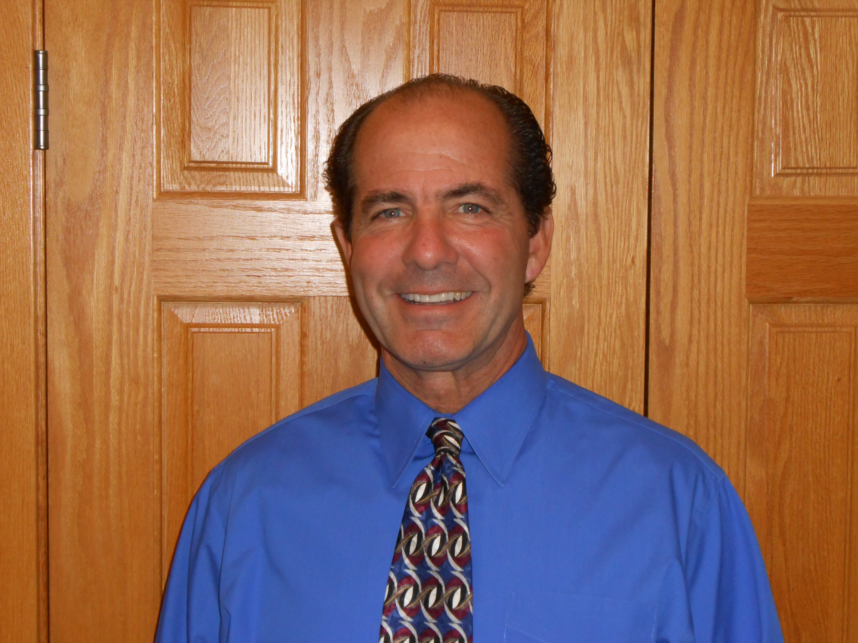
Prior to coming to the City, my background entailed 30 plus years of executive and senior management positions primarily at Bristol-Myers Squibb and Lockheed Martin in Syracuse. I also served as one of your City Commissioners for 8 years and, over the years, have been involved with many volunteer activities throughout Central New York. I spent most of my youth growing up in Sherrill and I have lived all of my adult life in Sherrill where I have constructed a number of homes and buildings. My three boys, Michael, Matthew and Kevin, were also raised here. I currently reside on West Hamilton Avenue with my wife Mary Lou.

My approach to this position is simple: Every decision I make will be what I feel is in the best interest of our City and residents. I will always be available, open to constructive comments and ideas, and, most importantly, work hard to get the job done.

I want to take a moment to congratulate Bob Comis on his well-deserved retirement and thank him for all he has contributed to our community and also for his generosity in helping me transition to my new role.

Again, thank you for giving me this opportunity. If you see me out walking the streets, which I do regularly, feel free say hello and let me know how we can all serve you better. Enjoy the beautiful blue skies and foliage in the coming weeks. God Bless you and your families.

Michael R. Sayles

What’s Inside

Fire, Police & DPW News page 2

CAC Programs and Events page 3

Library Information page 4

Church & Organization News page 5

Sherrill Business News page 6

Assessor & Water News page 7



Thank you to The Gorman Foundation for sponsoring Sherrill’s Summer Concert Series! It was wonderful to see so many great performances!
Department of Public Works Reminders

Transfer Station Information- The transfer station will be open Wednesdays 3:30-5:30pm and Saturdays 8am-1pm until October 31. After that it will be open only on Saturdays. The transfer station is for city residents. Residents must purchase coupons at City Hall, in order to drop off items at the transfer station.

Garbage Pick Up Date Changes- Pick-up in the Village of Vernon changes from Thursdays to Tuesdays on the following dates- November 27 changes to November 25, December 25 changes to December 23, January 1 changes to December 30.

Brush and Green Waste Pick-Up Remaining Dates- Every other Monday- October 6 & October 20. Please wait until the weekend before pickup to put out brush. After October 21 all brush must be taken to the City’s transfer station at no charge. The City will start to pick up leaves when the weather dictates. Leaves are used for composting so please do not put branches, sticks, or twigs in with your leaves. Please rake leaves to the curb or bag them.

Plastics Recycling Information- The following plastics, with and without recycling number codes, should be placed in your recycling container loosely with no plastic bags, string or twine: soda bottles, milk & water jugs, mustard & ketchup bottles, baked good containers, disposable drink cups, soap & detergent bottles, mouthwash bottles, salad dressing bottles, peanut butter jars, milk cartons, juice cartons, juice boxes. Lids should be left on containers. Containers should be empty and rinsed before recycling. The following items are not accepted for recycling: styrofoam, plastic bags & packaging, plates & tableware, prescription medicine bottles, motor oil bottles, clothes hangers, furniture, needles & syringes, six-pack holders, snack bags, toys, straws, plexiglass, or pesticides. For more information please visit www.ohswa.org.

Police Department Reminders

Please note the following phone numbers- For emergencies call 911, to file a police report or if you have a police related question you’d like to speak to an officer about call 363-3200, to leave a message for an officer on an existing case or to leave information if you are going on vacation call 363-6221. Please do not call City Hall about police matters.

-The “No Parking” on city streets ordinance resumes November 1-April 30. This ordinance applies to all streets between 2-7am.

-Studded tires are allowed October 15-May 1.

-School is back in session! Drivers should stop for all stopped school buses, as well as be aware of children crossing the roads.

From the Fire Department

The Fire Department would like to thank everyone who participated in and turned out for our 100 year anniversary. Thank you for your support.

Time Changes Mean Battery Changes- Don’t forget to change the batteries in your smoke detectors and carbon monoxide detectors every fall when setting your clocks back for the end of Daylight Savings Time.

Fire Extinguishers- Fall is a good time to make sure that all your fire extinguishers are fully charged and in working order.

Central Heating System Safety Tips- Get your central heating system cleaned, inspected and serviced by a certified HVAC contractor every year before using it. If you have a gas heater, make sure you have a sufficient quantity of fully functioning carbon monoxide detectors in your home.

Fireplace Safety Tips-
-Hire a chimney sweep to clean out your chimney every fall.
-Repair any cracks in fireplaces.
-Use fireplace screens to keep sparks and fire debris inside the fireplace.
-Never leave a fire unattended.
-Make sure that combustible materials not stored within 3 feet of the fireplace.
-Remember outdoor fireplaces can be just as dangerous as indoor units, and observe all safety precautions when using them.
Safety tips from Grand Traverse Metro Emergency Services Authority

Halloween Night at the Fire Department- Stop by from 6:30-8pm! The Fire Department will be teaching tricks on how to stay safe on Halloween and treats will be handed out!

Santa’s Ride- Chief Davis has been in contact with the North Pole and has confirmed that Santa will be making a stop in Sherrill on Sunday, December 7, in preparation for Christmas. Keep a look out for additional information about the day!

Community Activity Center News
Stop by or call 363-6525 for more information!
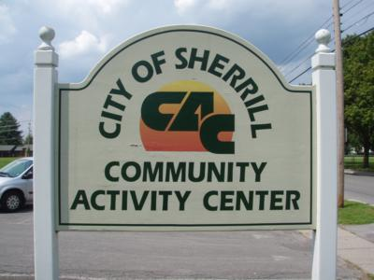

Bowling Hours- Wednesdays 11am-2pm, Fridays 6-11pm or 9:30-11pm (because of a league every other Friday), Saturdays 1-5pm and 9:30-11pm, Sundays 12-5pm; Please call for hours on school half days, holidays and snow days.
Adult Pool League- The adult pool league is looking for players for Fall/Winter 2014. Call for more information.

Ongoing Programs and Events
Mondays
Bone Builders- Strength Training for the Older Adult, 9am, Contact Polly 853-6258. $1.50/class

Tuesdays
Community Fine Arts Guild- Join this group of artists 9am-12pm to paint, work together, share ideas, and to have the opportunity for critique, if desired.

Wednesdays
Oneida County Office for the Aging- On the first Wednesday of every month at 11am a representative is at the CAC to provide people ages 60 and over, and people of any age with disabilities, with many services.
CAC Craft and Chat Group- Join this group the first, third and fifth Wednesday of each month, 11am-1pm, to knit, sew, or create any other craft. Buy lunch at the CAC or bring your own.

Thursdays
Rescue Me K-9 Dog Rescue Dog Socialization Classes- Come to these free classes for anybody who wants to bring their dog. Donations are accepted. Thursdays 6-7pm, Contact Debbie Martin, 829-3454 with questions.

Daily Programs
Walking in the gym- This is a self-monitored program open to all, weekday mornings 8-9:30am.

Kids Play Time- Monday-Friday, 9:30am-12pm- Parents are welcome to bring their children, ages 5 and younger, for indoor play in the gym. Some toys are available or bring your own! Children must be supervised by an adult.
2014-2015 City of Sherrill Youth Center Information
VVS students in grades 4-12 are invited to attend youth center beginning October 6 and running through early spring at the Sherrill Community Activity Center. Youth Center will be open Monday and Tuesday, 6-9pm, for students in grades 4-6 and Friday and Saturday, 6:30-10pm, for students in grades 7-12. Special events and schedule changes will be posted throughout the season. Parents who have children who attend youth center must fill out paperwork for 2014 which is available at the CAC, City Hall or www.sherrillny.org. VVS students who do not live in the City of Sherrill or the Town of Vernon must purchase a ticket or season pass to attend youth center. Tickets and passes are available at the CAC or City Hall. Please call the CAC with questions.

Junior Bowling Leagues
There will be a Thursday league for bowlers 8-12 years old beginning October 2 and Saturday leagues for bowlers 5 years old and older beginning October 4. There is a $5 registration fee and weekly fees for bowling. If bowlers missed registration they may still join providing there are spots available. These leagues are for everyone- there are no restrictions about where bowlers live or go to school. Please contact the CAC or Allen Glover, 363-1748 for additional information.

Special Events
Winter Craft Show- December 6, 9am-3pm- Vendors will sell crafts and other items. Food will be available for purchase.

Winter Playground- Children who attend E.A. McAllister who are in pre-kindergarten-sixth grade are invited to participate in activities at the CAC during the holiday vacation. Please look for more information at the CAC or at www.sherrillny.org in early December.

Birthday Parties and Events
Have a bowling birthday party or another event at the CAC! Or if you are interested in teaching a class at the CAC please call for more information.

Sherrill-Kenwood Free Library News
Stop by, call 363-5980, “Like” the library on Facebook, or visit www.sherrillkenwoodlibrary.org for more information!

Did you know that the library only receives 54% of its funding through stable funding sources?
Please consider donating to the library to help us continue to serve the community. As always, your donations to the library are tax deductible. If you would like to make a donation, or would like more information about library funding, contact Jennifer Milligan at 363-5980.

Family Movie Night at the Library
Come to the library at 6pm for a free night at the movies! Popcorn & juice will be provided.
October 8: Curse of the Were-Rabbit
October 22: Casper
October 15: Mr. Peabody & Sherman
October 29: Ghostbusters
Check back at the library for the schedule of movies for November & December including How to Train Your Dragon 2 and Teenage Mutant Ninja Turtles!

After School @ the Library
Mondays, 3-5pm: Lego Club
Wednesdays, 3-5pm: Gaming Club
Thursdays, 3:15 pm: October 2, 9, 16, 23: Art Classes for Ages 7-11. Cost is $30.00. All materials are included. Space is limited so register today!

Creation Lab
October 25, November 15, December 13, 11am- Stop by the library for the chance to be creative! There will be Legos, Play-Doh, beads, and other miscellaneous seasonal craft supplies available for you to use and create!

Space Scavenger Hunt- September & October
Get a scavenger hunt sheet from the front desk. Successfully complete the scavenger hunt and select a great prize provided by NASA!

Sleepytime Stories
September 18, October 16, November 13,
December 18, 7pm

Family Story Hour
Tuesdays, 11am starting October 7
Book Discussion Group
Grassroots Read- The Dirty Life by Kristin Kimball- October 1, 6:30pm
Flipped by Wendelin Van Draanen- December 3, 6:30pm- Books are available at the library and everyone is welcome to attend the discussions!

Star Wars Reads Day
October 11, 11am- Come to the library for a celebration of Star Wars! Wear your costume and win a prize! There will be stories and crafts and fun things to take home!

Tangles Art Class - RESCHEDULED
November 7, 5-7:30pm & November 8, 11am-1:30pm- The cost of this 2-part class is $25 and includes supplies and light refreshments. At the end of each class, Suzi will randomly give away one of her framed completed works! Space is limited- participants must register in advance by calling the library at 363-5980. The $25 fee is due by October 31.

Watercolor Holiday Cards
November 22 from 10am–1pm- Join instructor Laura Diddle in creating beautiful watercolor cards for the holidays! The fee for the class is $10. Space is limited- call today to register!

Artist Reception & Raffle!
The annual Artist Raffle is back! Art will be on display during the month of November with tickets for sale for $3 each or 4 for $10. Winners will be drawn on Saturday, December 6 during the Artist Reception from 10am-12pm.

Church News

Sunday School and Youth Group
at Plymouth Alliance Church
Plymouth Alliance Church invites everyone aged 2 and older to participate in weekly Sunday School classes from 9:15-10:15am, before Sunday church service, which begins at 10:30am. The Sunday School setting is less formal than Sunday church service. It’s a wonderful time to ask questions, offer opinions and interact with the presenter and other members of the class while learning more about God. The church currently has 4 classes for school-aged children and 3 different classes for adults. Why not make it a point to join us next Sunday to see what Sunday School is all about? We’d be glad to have you!

Plymouth Alliance Church also invites area teenagers to attend their weekly Youth Group. Meetings are held every Sunday from 6-8pm at the Kenwood location, 102 Cramer Ave, Oneida. Youth Group is a chance to spend time with other teens, enjoy some games, music and activities, and learn about God by reading the Bible and having a short discussion about it. Any teenager in grades 7-12 is welcome- you do not need to attend Plymouth Alliance Church to participate. Pastor Kurt Johnson is available if you have any questions regarding either Sunday School, youth group activities at Kenwood or church services at Plymouth Alliance. He can be contacted at 315-363-5642 or KurtPAC@twcny.rr.com.
Gethsemane Church Fall Rummage Sale Saturday, October 4, 9am-2pm, 320 Park Street
Items for sale will include:
Women's, men's, & kid's clothing & shoes
Kitchenware, glassware & dishes
Halloween & Christmas items
Jewelry, purses, toys & games
Home décor, furniture & antiques!
From 12-2 there will be a clothing & shoe bag sale.
All other items are 1/2 price from 12-2.



News from Sherrill Organizations

Sherrill Garden Club Upcoming Meetings
The Sherrill Garden Club will host a speaker from the Nature Conservancy for their October 7 meeting at 7pm in the conference room of the Sherrill-Kenwood Free Library. The topic for the meeting is how to combat invasive species with prevention and control to protect native plants and animals. For the November meeting Kim Adamkowski from Freedom Farms will return to present a program on decorating for the holidays with natural materials. The December meeting will include decorating the Christmas tree in the library, collecting gifts to give to local DSO residents and a white elephant auction to benefits the World Gardening’s Water for Sudan project. Visitors are always welcomed to join the meetings as the group continues to learn how to benefit and serve the community.
Sherrill-Kenwood Community Chest 2014 News
Please look for the Sherrill-Kenwood Community Chest’s 2014 fund drive mailing. 100% of donations received are used to help fund area programs which rely on the community’s support. Your generosity is appreciated.

Sherrill American Legion Post 230 Upcoming Events
October 25 Kids Halloween Party, 1-3pm
November 4 Election Day Spaghetti Dinner, 430-7pm
November 8 Veterans Day/Early Bird Dinner, 6pm
November 11 Veterans Day Ceremony at Triangle Park, 11am
December 13 Pancakes with Santa, 8-11am
Also- SAL is holding a Gun Raffle. Win a Marlin X7 or $300. Tickets are available for $5 by calling 363-3920 or contacting Brian Leach.

News from Local Businesses


Sweetback Sisters Country Christmas Singalong Spectacular: On Friday December 19 at 8pm the Earlville Opera House brings back the Sweetback Sisters with their swinging, razor sharp band for a concert at the Oneida Community Mansion House. Advance tickets are $20 for adults and $10 for youth. Add $2 day of show. For tickets or more information, call the EOH at 691-3550 or visit www.earlvilleoperahouse.com The Oneida Community Mansion House is located at 170 Kenwood Ave, Oneida.

Message from Judy Stevens, owner of Enchanted Touch Massage Therapy: As most of you noticed I closed my office in June. I shared with many of you that I have been battling Multiple Sclerosis since 2007. In January I dealt with a relapse causing more symptoms. After much debate and discussion with my husband Matt and family, I decided I needed to follow my neurologist's advice and close my massage therapy office. I wish to thank the City of Sherrill for being such a great place to start and have a business and also the other business owners who were always supportive. But mostly I wish to thank the many people who came to see me for massage. Over the past 3 years many of you have become more than just clients, you became good friends. I have many massage therapists ask me what I did to make my massage therapy office as successful as it was, without a doubt it was the many wonderful people who I met and that came to see me. Thank you!

Attention Men and Boys: Sherrill has its very own Master Barber! Sherrill native and VVS 2011 graduate Mike Piazza is now working at Salon 129 located next to the NY Pizzeria. Mike graduated from the Shear Ego International Institute in Rochester in April and is NYS certified. Haircuts, hair styling, straight razor shaves, mustache & beard trims, and facial massages are all services Mike provides. Hours are Tuesday- Saturday 9am-5pm or call 527-8837 to schedule an appointment convenient for you- Mike will work with your schedule. Enjoy the unique combination of old school training and cutting edge style.

Noyes Real Estate News: Noyes Real Estate is delighted to announce that Sherrill’s very own Kim Frarey has joined their team of agents. Kim has worked with Madison County ARC and Cornue’s Children's Corner, while also working at Cierek Reality Inc. Kim assisted Cindi Cornue in finding a new location for Cornue's Children's Corner in Sherrill. Kim is an alumna of Cazenovia College. She is a fourth generation realtor and her experience makes her uniquely qualified to sell real estate. Kim joins fellow agents; Judy Noyes(Broker), Tom Busek, Rebecca Crane, Jennifer Dapson, and Ashley Caraher. If you have a house you would like to sell or have an interest in purchasing one, contact Kim, k.frarey@icloud.com or 225-3799.

Opening October 2014
Tuesday - Saturday 10am-4:30pm
622 Sherrill Road
(formerly Yankee LTD)

Sherrill Merchants Association News

Fall Festival



The Sherrill Merchants Association will host a fall festival November 1 from 12-3pm at the CAC! Bring your carved pumpkin and participate in a pumpkin carving contest with awards for different age groups! Sample chili and fall foods from various restaurants and vote for your favorites! Participate in games and learn about Sherrill businesses!

Tree Lighting



The Sherrill Merchants Association will host a tree lighting ceremony on December 4 in Reilly-Mumford Park! Look for more information coming soon.

The Sherrill Merchants Association is a group of businesses that promotes local business, provides networking opportunities, shares resources and hosts community events. Meetings are held the 2nd and 4th Wednesday of the month at 8am, at the CAC. New members welcome- for more information contact Vicki Andrews, 363-5638 or vandrews@marykay.com.

City of Sherrill
Contact Information



City Commissioners

William Vineall, Mayor
366-5430 or mayor@sherrillny.org

Jeffrey Gilbert, Deputy Mayor
813-3301 or jgills@aol.com

Michael Hennessy
363-0307 or mhenn0307@yahoo.com

Patrick Hubbard
363-3379 or phubbard66@hotmail.com

Jason Merrill
361-5242 or Jmerrill427@gmail.com

City Officials

Michael Sayles, City Manager
363-2440 or msayles@sherrillny.org

Michael Holmes, City Clerk/Comptroller
363-2440 or mholmes@sherrillny.org

Please contact City Hall, 363-2440 with other questions.

Assessor News
Enhanced STAR- For those individuals that will be turning 65 in 2015 and not currently receiving the Enhanced STAR school property tax exemption- you are considered 65 for the Enhanced STAR exemption on January 1, 2015 regardless of when your birthday is in 2015. For those property owners currently receiving Enhanced STAR school property tax exemption who are not signed up for the automatic renewal it is time to renew your exemption! The 2015 Enhanced STAR combined income is $83,300 based on your 2013 income. Those applying for a new or renewed Enhanced STAR exemption may elect to participate in a voluntary program whereby the Assessor’s office is automatically notified in future years by the State regarding the income eligibility of the applicant(s). This “automatic” process is only useful for those filing New York State income tax returns. Applications for the “Income Verification Program” are available at the Assessor’s office. This “automatic” process cannot be used for any other income-related exemption application such as and including the Senior Citizen’s exemption application.

Basic STAR- For those not receiving the Basic STAR property tax exemption for their primary residence, this exemption is not age limited and the income level is $500,000. Basic STAR requires an initial application only. If you have recently purchased a residence in Sherrill or have not previously applied for the Basic STAR exemption, you may qualify for this significant property tax exemption designed to lower your school tax bill.

All exemption applications are required to be submitted to the Assessor for processing prior to March 1, 2015. Please contact City Assessor Bob Comis at 264-6362 with any questions. Bob will be scheduling dates and times at City Hall to process your Enhanced STAR and Basic STAR forms. The dates will be posted on the City’s website.

City of Sherrill HEPA Vacuum Loaner
The Oneida County Health Department has provided the City of Sherrill with a HEPA vacuum that area residents can use to aid in removal of paint containing lead and lead dust in their homes. The vacuum cannot remove attached paint, but can remove unattached paint flakes. Lead dust can be generated by opening and closing windows. During a “spring cleaning” the vacuum can be used to remove dust in areas where it might accumulate such as window grooves, tracks and sills. Area residents may borrow the vacuum for up to three days by providing identification and signing out the vacuum at Sherrill City Hall. Vacuum supplies and use instructions are provided and there is no cost for this service. Please note- contractors may not borrow the vacuum as they are required to follow specific procedures for lead removal.

Water Main Flushing
Water mains will be flushed on the following dates: October 20- Route 5, Prospect Street, Rowland Place and the entire north side of the city, October 21- streets west of Sherrill Road, October 22- streets east of Sherrill Road, October 23- Kenwood streets. Businesses and residents may experience dirty water and low pressure during the week.

PRESORTED
STANDARD
US Postage Paid
Sherrill, NY Permit No. 7

City of Sherrill
377 Sherrill Road
Sherrill, New York 13461



